Weilin Lu

CS-699 HW2

Question 1

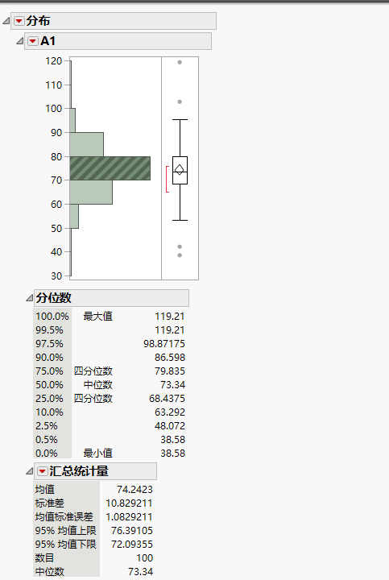

1:mean = 74.2423; median = 73.34; standard deviation = 10.829211

2:Q1 = 68.4375; Q2 = 73.34; Q3 = 79.835

3:IQR = Q3-Q1=79.835-68.4375=11.3975

4:

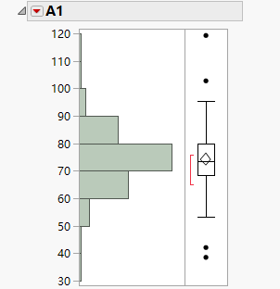

Question2:

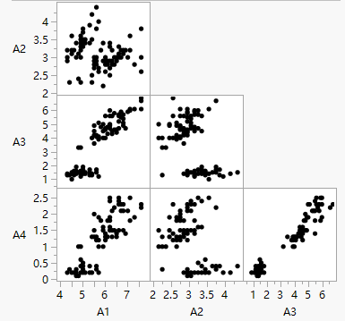

By visual observation, it seems like A1A3 and A3A4 have the strongest correlation.

Question3:

d(P8,P9)=(p-m)/p=(7-2)/7=5/7

d(P8,P10)=(p-m)/p=(7-2)/7=5/7

According to the result showed above, they have same distance

Question4:

|  |  |  |  |  |
| --- | --- | --- | --- | --- |
| Object | A1 | A2 | A3 | A4 |
| O1 | 2 | 0.5 | 1 | 1 |
| O2 | 5 | 1 | 0.5 | 0 |

D(O1,O2)=Sqr root{(2-5)^2+(0.5-1)^2+(1-0.5)^2+(1-0)^2}=3.24

Question5:

A1:|27-52|/(73-12)=0.41

A2:1

A3:1

A4:1

A6: 1

A7:|0.5-0|/(1-0)=0.5

D(T6,T7)=(0.41+1+1+1+1+0.5)/6 =0.82

Question6:

D1*D2=(3*1+3*1+2*0+1*3+2*4+2*2+4*2+2*3+2*1+1*1)=38

D1*D3=(3*2+3*2+2*1+1*4+2*0+2*1+4*0+2*1+2*2+1*2)=28

||D1||=(3*3+3*3+2*2+1*1+2*2+2*2+4*4+2*2+2*2+1*1)^0.5=7.48

||D2||=(1*1+1*1+0*0+3*3+4*4+2*2+2*2+3*3+1*1+1*1)^0.5=6.78

||D3||=(2*2+2*2+1*1+4*4+0*0+*1+0*0+1*1+1*1+2*2)^0.5=5.92

cos(D1,D2)=38/(7.48*6.78)=0.75

cos(D1,D3)=28/(7.48*5.92)=0.63

So, D1 is closer to D3